Numeral Attribute

✅ What is Numeral Attribute?
# Source: AI Source: Provided by: [Data Path: Persons Table -> ID Column: 1, Name_En Column: Motasem Essam] -> From: [Chatgpt (GPT‑5 Mini)] on [8/7/2025]
A Numeral Attribute is a number or number-related expression that modifies a noun by indicating quantity, order, or amount. It functions attributively, appearing before the noun it modifies.

🔹 Key Features:
# Source: AI Source: Provided by: [Data Path: Persons Table -> ID Column: 1, Name_En Column: Motasem Essam] -> From: [Chatgpt (GPT‑5 Mini)] on [8/7/2025]
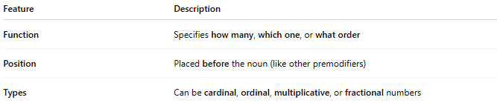
Feature | Description
Function | Specifies how many, which one, or what order
Position | Placed before the noun (like other premodifiers)
Types | Can be cardinal, ordinal, multiplicative, or fractional numbers

🔹 Forms of Numeral Attributes:
# Source: AI Source: Provided by: [Data Path: Persons Table -> ID Column: 1, Name_En Column: Motasem Essam] -> From: [Chatgpt (GPT‑5 Mini)] on [8/7/2025]
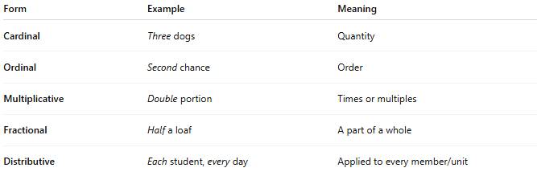
Form | Example | Meaning
Cardinal | Three dogs | Quantity
Ordinal | Second chance | Order
Multiplicative | Double portion | Times or multiples
Fractional | Half a loaf | A part of a whole
Distributive | Each student, every day | Applied to every member/unit

🔹 Examples in Sentences:
# Source: AI Source: Provided by: [Data Path: Persons Table -> ID Column: 1, Name_En Column: Motasem Essam] -> From: [Chatgpt (GPT‑5 Mini)] on [8/7/2025]
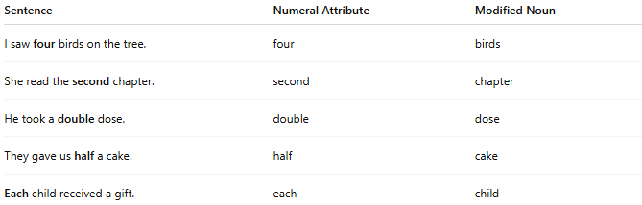
Sentence | Numeral Attribute | Modified Noun
I saw four birds on the tree. | four | birds
She read the second chapter. | second | chapter
He took a double dose. | double | dose
They gave us half a cake. | half | cake
Each child received a gift. | each | child

🔹 Comparison with Other Attributes:
# Source: AI Source: Provided by: [Data Path: Persons Table -> ID Column: 1, Name_En Column: Motasem Essam] -> From: [Chatgpt (GPT‑5 Mini)] on [8/7/2025]
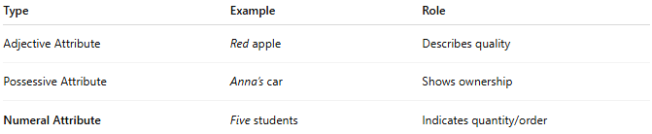
Type | Example | Role
Adjective Attribute | Red apple | Describes quality
Possessive Attribute | Anna’s car | Shows ownership
Numeral Attribute | Five students | Indicates quantity/order

